PRELIMIN Y CONFERENCE

Doctors Hospital of
Arbitrator(s):
Zela G. Claiborne Richard Chernick George H. King
Counsel:
Stephen L. Goff Esq.
Scott Cameron Esq. Marcia L. Augsburger Esq.
King & Spalding 621 Capitol Mall
Suite 1500
Sacramento, CA 95814
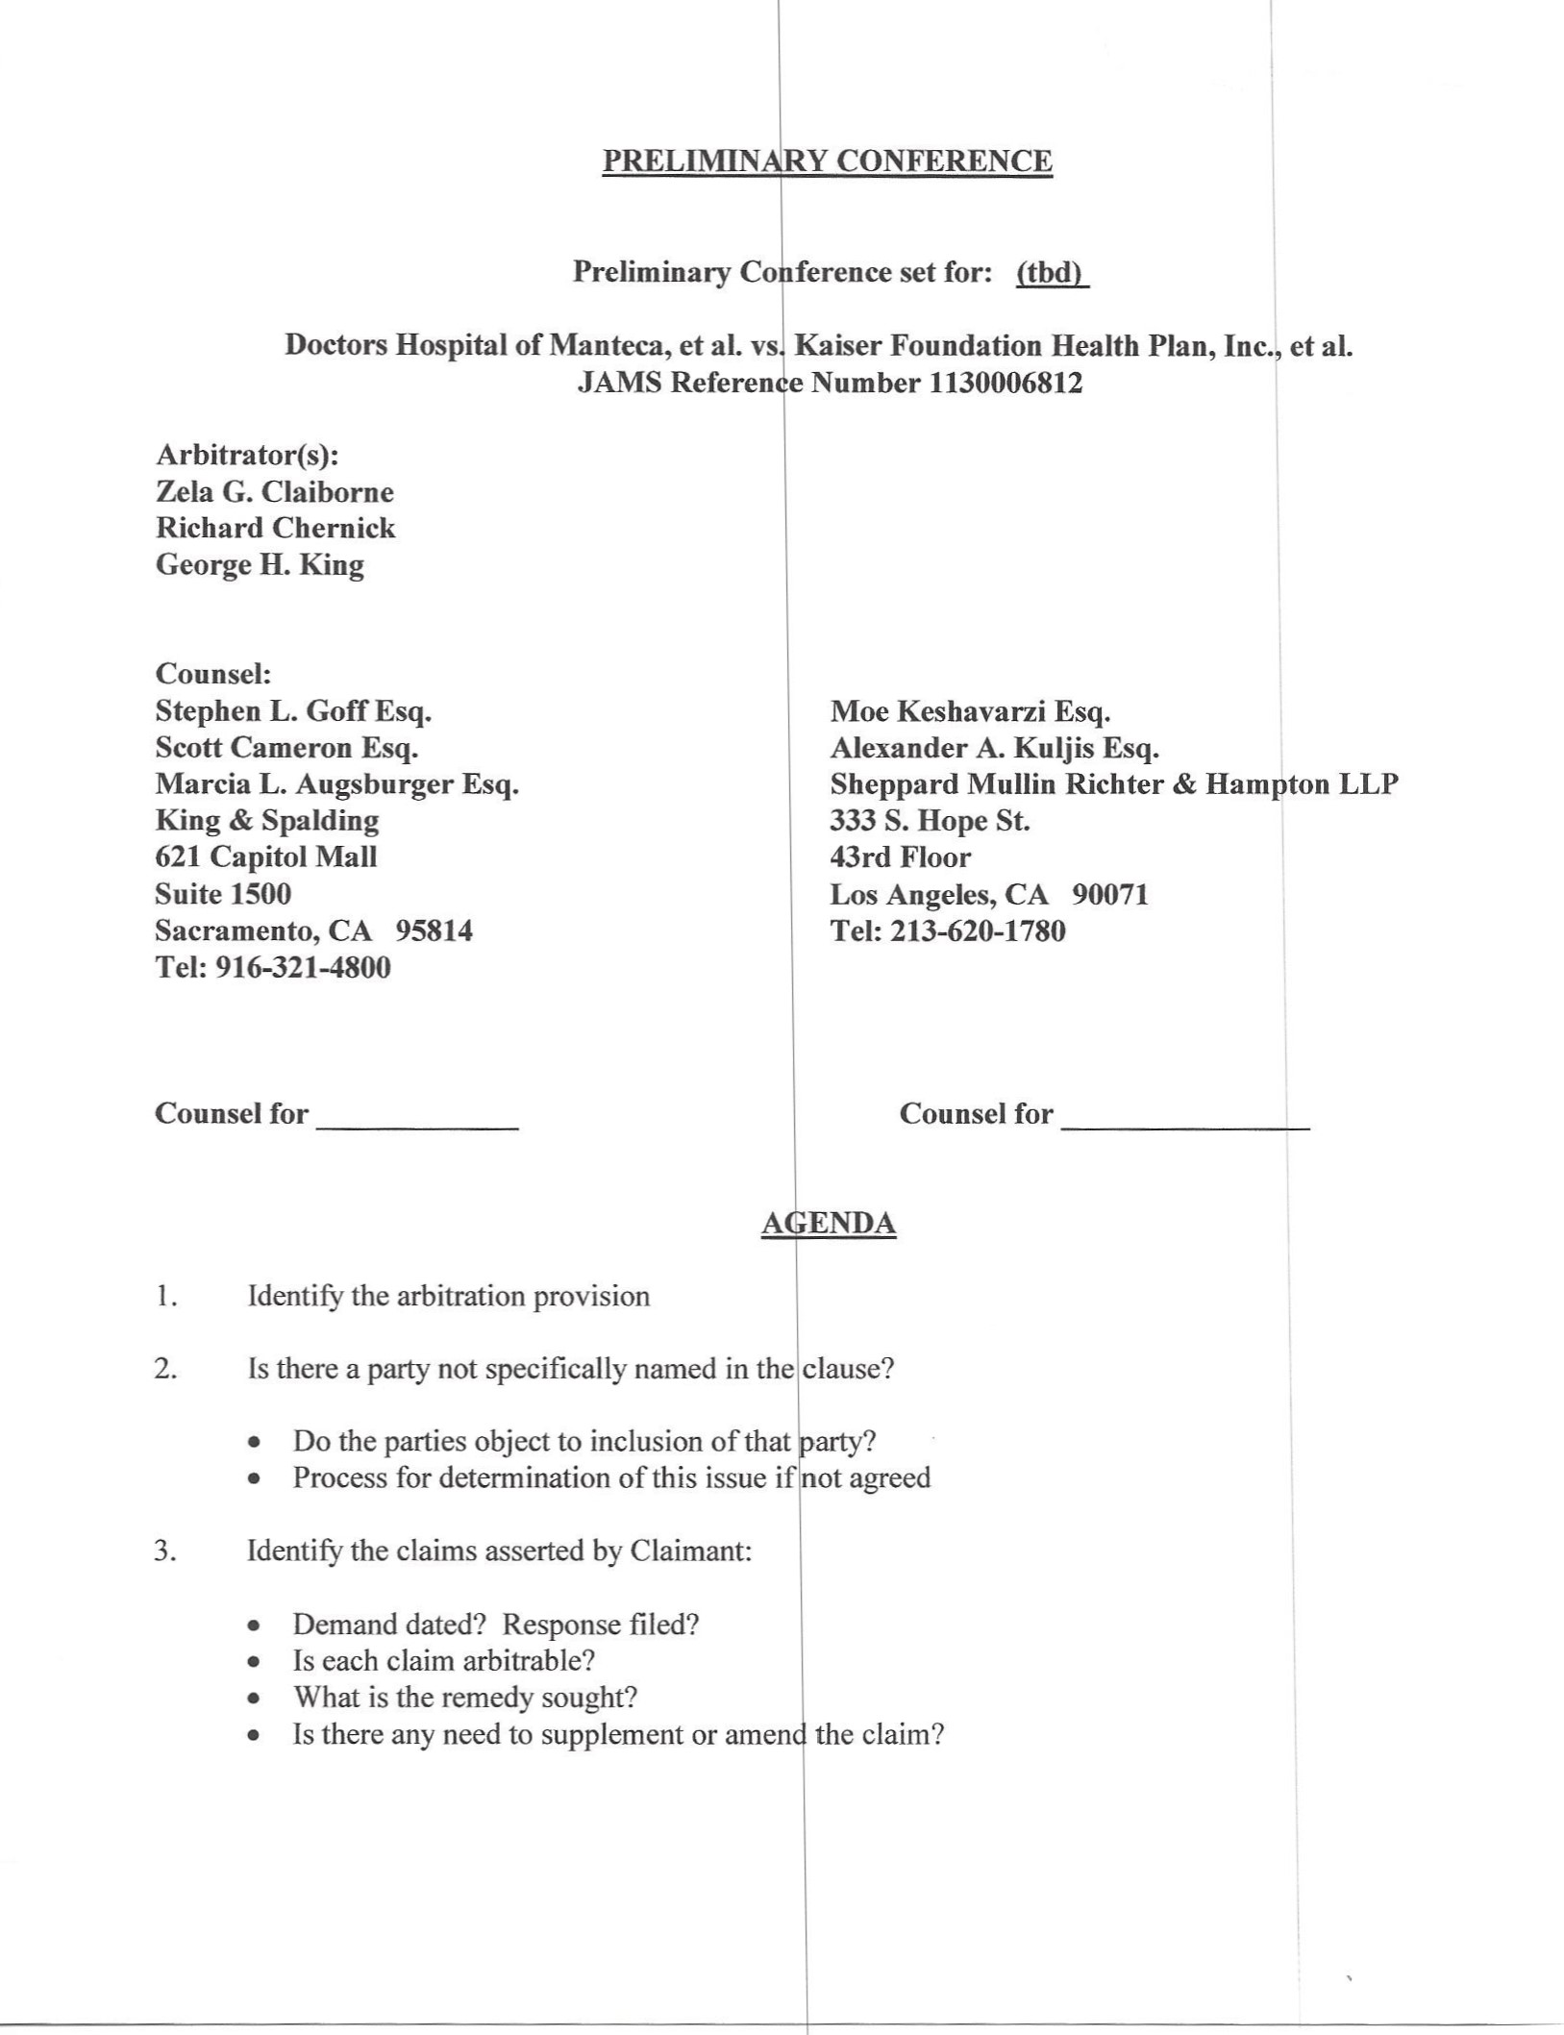
Tel: 916-321-4800
Counsel for

Health Plan, Inc. et al.
Esq.
Kuljis Esq.
Richter & Hampton LLP
90071

4.  5.  6.  7.  8.  9. 10. ll.  12.  13. | Is there a counterclaim? If so, see questio Appointment ofArbitrator and status of P  - Disclosures and supplemental disclosu  - Are Party Arbitrators to be neutral?  - If non-neutral, ex parte communicatio  - Disclosures as to prior exparte comm  What substantive law applies to the merits What arbitration law applies: FAA, Cal.  What rules apply: JAMS, AAA, CPR, 0th Will the parties agree to use the JAMS exped  Do the parties wish to conduct discovery or e  Does any party assert the right to conduct d for review by the Arbitrators?  - What discovery is authorized by the arb  - Nature of discovery sought—document  - Exchange witness lists identifying perci  - Expert designation/exchange of reports  - Will any percipient witnesses also give  - Witness statements in lieu of direct testi Timing  - Protective order?  - Discovery cut-off date  Are motions to be filed?  - Identify, state the basis for the motion,  - Briefing schedule and hearing date  - Last day to file before hearings  Prehearing matters  - Referral of routine matters to the Chair  - Bifurcation of issues?  - Exchange of exhibits (non-impeachment  - Preparation and pre-marking of single e  - Identify exhibits as to which objection | s at #3.  Arbitrators, if applicable es  s after prelim.?  nications, if applicable  b. Act, Cal. Int'l Arb. Act?  r?  ted procedures?  change information informally?  scovery? Date for counsel to provide a discovery plan  tration agreement or applicable rules? xchange, depositions? ient witnesses  xpert opinions?  ony with live cross-examination at hearings?  d request permission to file  o the Arbitration Panel?  ibit list  Il be made (remainder are deemed admitted)

- Other exchanges?
- Stipulation of facts?
- Hearing procedure
  - Dates of hearing
  - Place and time of hearing
  - Filing of pre-hearing briefs
  - Reporter? cost sharing and allocation award
  - Will any witness testify other than in p rson? By video, Skype, other?
  - Disclosure date:
Objection date:
  - Closing argument and/or post-hearing riefs?
- Form of award
  - Timing of issuance (30 days or more?)
  - Attorneys' fees and costs?
• | Briefs are to be posted on Case Anywhe is a good idea to hand-deliver or mail th | e but, if the materials are lengthy with numerous tabs, it m as well.
  - Interim/final awards?
- International arbitrations
  - Translation of documents? Interpreter?
  - Need for identity of interpreter to be a eed upon before hearings
- Administrative matters
  - Identification of Case Manager: Kathle n Hanley, khanley@jamsadr.com
  - Communications with Arbitrators dire y by email with copies to opposing counsel and Case Manager
  - The parties are encouraged to use Case nywhere, the JAMS electronic filing system: The costs are about $40 per firm per month lus $5 per filing. Hard copy filing and service costs (copying, postage, and messenger fees) e avoided, as are arbitrator fees for organization and administration. Documents are easi y submitted and filed with just a few cOmputer key strokes. A highly user-friendly, accessib e, reliable, and authoritative file is which greatly helps the arbitrators and saves the partie money. The system includes a convenient message board for easy informal communication ong lawyers, arbitrators, and Case Manager. It also features a capability for online storage o and access to deposition and hearing transcripts. (Hearing exhibits are not lodged on Cas Anywhere but may be submitted on a thumb drive.)

